Plan of Conservation and Development Implementation Committee
Regular Meeting Minutes
January 28, 2019
Present: Claire Frisbie, Frederick Knous, Chair; Angela Hammond,
Thomas Malecky, alternate
Absent: Wayne Martin, Frank Winiski, alternate, Sharon Peters,
Others Present: Ralph Zampano-BOS, Bernice Zampano, Parks & Recreation,
Elwin Guild, EDC, Kathy Herron, Complete Streets Group (CSG)
- Chairman Call Meeting to Order
Chairman Frederick Knous called the meeting to order at 7:09 p.m. in the Waverly Center (Senior Center) Conference Room in Town Hall, located at 7 Waverly Avenue, Portland, Connecticut and seated Thomas Malecky. He distributed a policy statement from the Complete Streets Group.
- Approval of Minutes
Chairman Frederick Knous entertained a motion to approve the December 6, 2018 meeting minutes. A motion to approve the December 6, 2018 meeting minutes was made by Claire Frisbie, seconded by Thomas Malecky. Vote unanimous. Motion carried.
- Update 2019 Calendar
Chairman Knous entertained a motion to approve the 2019 meeting calendar. A motion to approve the calendar was made by Claire Frisbie, second by Angela. Vote unanimous. Motion carried,
- Discussion with Town Officials and Policy Partners
Chairman Knous introduced Kathy Herron from the Complete Streets Group (CSG), who gave an overview of the group’s purpose and structure. She noted that the group was developed as an offshoot of the Arline Trail group in June 2014. The groups objectives are to make streets safer for all users and affect meaningful changes to that end.
Ms. Herron distributed the following information:
- Complete Street Policy for Portland
- CSG Update for POCID Implementation Committee
- CSG Recommendations for the RT 66 Corridor Study
- Priority Maps for cycling and sidewalks (part of our Complete Street Policy)
She then reviewed CSG activities to date relevant to the POCID Implementation Element
A.1 Strengthen the Town Center, Action item 7
Work with CT-DOT to improve RT 17, 17A, 66 intersections to accommodate pedestrians, bicyclists and vehicles.
CSG developed and sent a response to draft of 800-page RT 66 Corridor Study done by consultant Tighe & Bond (consultant).
A.3 Humanize the Streetscape, Action Items 1 and 2
Action item #1: Encourage creation and maintenance of a pedestrian friendly streetscape
CSG assisted in development of a Complete Streets Policy for Portland, which was approved by the BOS in Oct 2016. In the policy CSG identified areas of priority for sidewalks and possible bike routes.
Action item #2: Create a master vision for Main St to guide improvements to sidewalks
Three CSG members participated in the Sidewalk Committee that determined what sidewalks would be repaired using the $1,000,0000 bond money.
O.1 Policy 2: Consider traffic calming approaches if needed to protect the quality of life in residential neighborhoods.
CSG met with Susan Bransfield and Captain Milardo in January 2018 to discuss recommended measures. CSG purchased “Slow Down” signs. CSG participated in the Portland’s Speeding Concerns meeting in June 2018.
CSG purchased 36 “Please Slow Down” signs in 2018 and coordinated the posting of these signs in residential yards over the past year.
P1 Support Walking
Action item 5: Develop and implement a sidewalk improvement program
In addition to the activities noted in action items 1 and 2 (above) CSG also requested a “Road Safety Audit (RSA)” for Portland and brought to the town’s attention a Community Connectivity Grant Program, both of which resulted in bringing $200,000 more to Portland for Main Street sidewalks.
Action item #7: Adopt a Complete Streets Plan
CSG initiated and led, with assistance from consultant Brian Kent, the development and adoption of a Portland Complete Streets Policy. Requested approval from the BOS and it was unanimously approved in October 2016.
Q.1. Support Cycling
Policy item #1-Aspire to be a bike friendly community
Policy item #2-Create an overall system of bike routes Q1 Support Cycling Policy Item 1: Aspire to be a bike friendly community:
CSG developed two Portland bike routes, created google maps, and posted them on the town website. In Fall 2018, CSG requested money for bike route signage for the longer bike route (14 miles). The BOS unanimously approved up to $3,000 in current budget for signage. CSG is currently with the town Director of Public Works for purchase and installation of signs.
Kathy Herron noted the following recommended action Items:
- Invite CSG to participate in action items listed in the Implementation Element that lists CSG as a partner
- Make redesign of RT 66 from RT 17A (Main Street) to RT 17 (Gospel Lane) a priority given two current projects: 1) RT 66 Corridor Study and 2) Economic Development in the downtown area.
- Hire a full-time town planner (with planner certification and experience).
- Review the 2016-2018 Plan of Conservation & Development
Chairman Knous reviewed the draft and suggested adding an indicate when the action item is complete. Angela Hammond suggested changing the Received On column to Status column.
There was discussion regarding the best way to identify action items in the document. Claire Frisbee suggested shading the action items to help them stand out.
- Public Comment: None
- Adjourn Meeting
Chairman Knous entertained a motion for adjournment. Angela Hammond made motion to adjourn the meeting, motion seconded by Thomas Malecky. The meeting adjourned at 9:13 p.m.
Respectfully submitted,
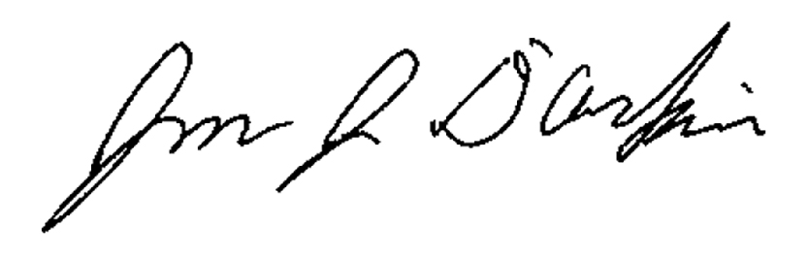
Jon D’Arpino, Recording Clerk
January 30, 2019
CC: Frederick Knous, Angela Hammond

